**Underwater Compressed Air Energy storage in Antigua and Barbuda**

Yang Cao

19/5/2014

**Background**

Antigua and Barbuda is a twin-island country lying between the Caribbean Sea and the Atlantic Ocean. The small island is under threat from high imported diesel costs. According to a report from the Ministry of Agriculture, Lands, Housing and the Environment, they plan to integrate 18 MW of wind and 5 MW of solar power into its existing power grid [1]. The high variance of wind and solar energy results in wasted power at certain times of the year, while at other times demand exceeds generated power and results in loss of power reliability. It is therefore desired to implement methods of energy storage and off-peak usage such that waste is minimized. Underwater Compressed Air Energy Storage (UW-CAES) is evaluated as a method to better meet the demand and improve the utilization of renewable energy.

**Part 1- Optimizing electricity supply by involving energy storage**

1. Data Processing

Demand data was collected every half hour from 1/1/11 0:00 to 12/31/11 23:30. The average wind speed at five wind sites and solar irradiation (in watts per square meter) are collected every 10 minutes from 1/6/11 9:40 to 8/14/12 8:50. We transformed all the data to hourly basis and only used the overlapped time range, from 1/7/11 0:00 to 12/31/11 23:00, 8616 hours in total. The potential generation of renewable energy is calculated based on the hourly wind speed and hourly solar irradiation.

1. 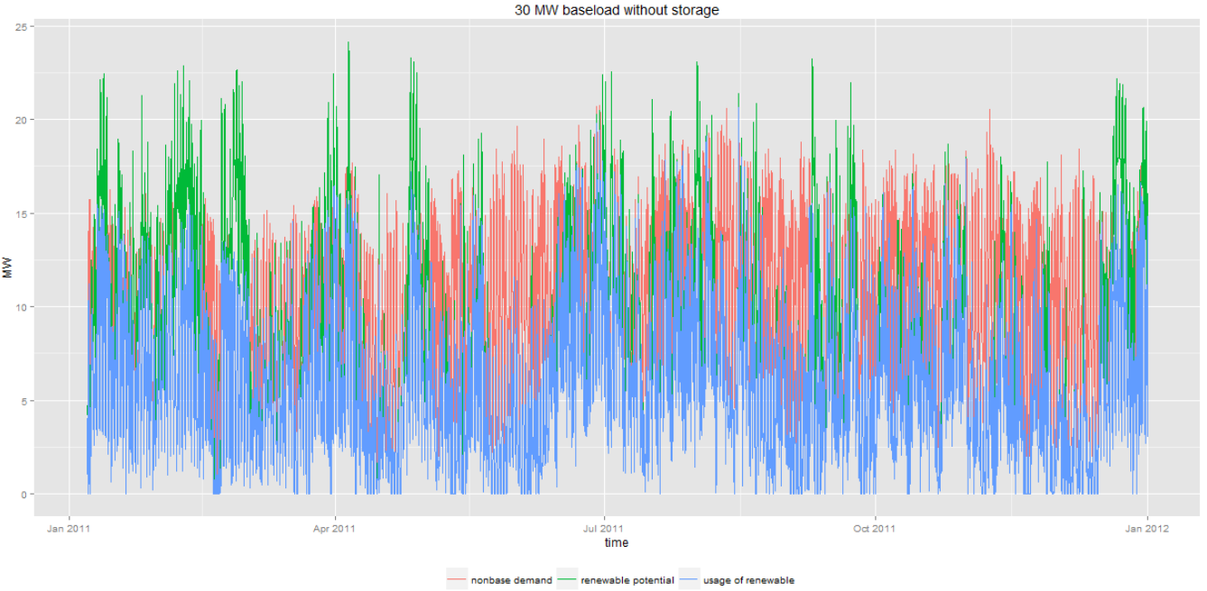Potential Renewable Energy Generation

Fig. 1 Non-base demand, renewable potential and renewable usage profile without energy storage

As shown in Figure 1, energy generation from wind and solar behave very differently from the non-base load demand. In first three months of the year, there is more renewable generation than demand, but the demand is much higher than generation in June and July. In total, there are 5191 hours the demand is not met in 2011. It will better meet the power demand, save cost for following up diesel and reduce waste to fill the unmet demand by the spilt renewables using energy storage.

1. Potential Wind Generation

The wind measurements recorded (2010 – 2012) at Crabbs, Guinea B, McNish, Freetown and Barbuda show that McNish yield the highest uncurtailed capacity factor and is accordingly the prioritized site for the planned 18 MW wind farm.

Table 1. Wind speed and generation for five wind sites of Antigua

|  |  |  |  |
| --- | --- | --- | --- |
| **Location** | **Annual wind speed** | |  |
| **at 60m** | **At hub height (80 m)** | **Uncurtailed capacity factor** |
| Crabbs | 7.2 | 7.92 | **0.367** |
| Guinea B. | 7.11 | 7.35 | **0.344** |
| McNish | 7.88 | 7.91 | **0.369** |
| Freetown*) | 6.59 | 7.55 | **0.279** |
| Barbuda | 6.47 | 6.98 | **0.112** |

1. Potential Solar generation

The potential power output of solar panels are calculated considering of the observed solar irradiation and ambient temperature’s effect on panels’ efficiency. The module model we chose is the First Solar® FS-387 [2] , which has arated power of 65.6W and an area of 0.72m2 per module. A 5 MW of capacity correspond to 76220 such panels which occupy 54878.4 m2 of area. According the solar irradiation and temperature data, the uncurtailed capacity factor of solar panels is 28.6%.

1. Total renewable energy generation

The average demand of the island is 39.5MW. However, according to the current configuration, the average supply including base-load generation and renewable generation will only be 37.6 MW.

$$P_{average gen}=P_{baseload}+P_{solar,rated}×{CF}_{solar,uncurtailed}+ P_{wind,rated}×{CF}_{wind,uncurtailed} \left(1\right)$$

1. Sizing energy storage

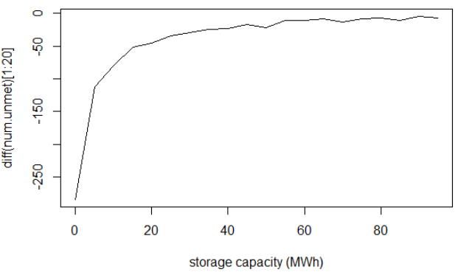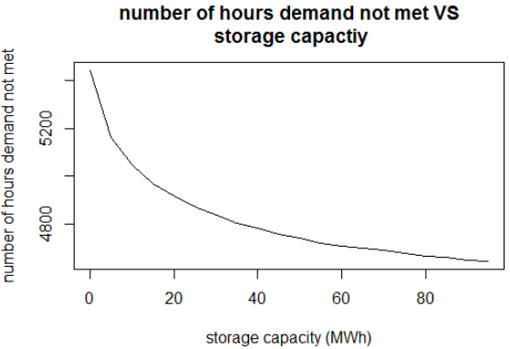

Fig. 2 Number of hours the demand is not met versus storage capacity Fig.3 The derivative of curve in fig. 2

Figure 2 shows the number of hours of unmet demand that can be reduced with different sizes of energy storage. As shown in figure 3, as the derivative of the numbers of hours with unmet demand levels out, the marginal unmet demand reduced by the increased capacity reaches its limit. 50 MWH is proposed as a cost-effective and reasonable size.

1. 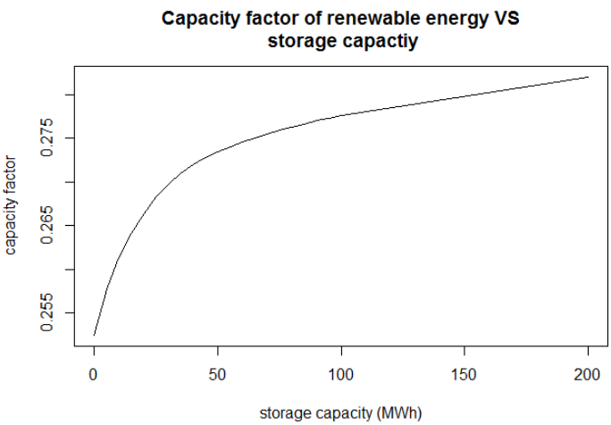The effect of energy storage

Fig.4 Capacity factor of renewable energies versus storage capacity

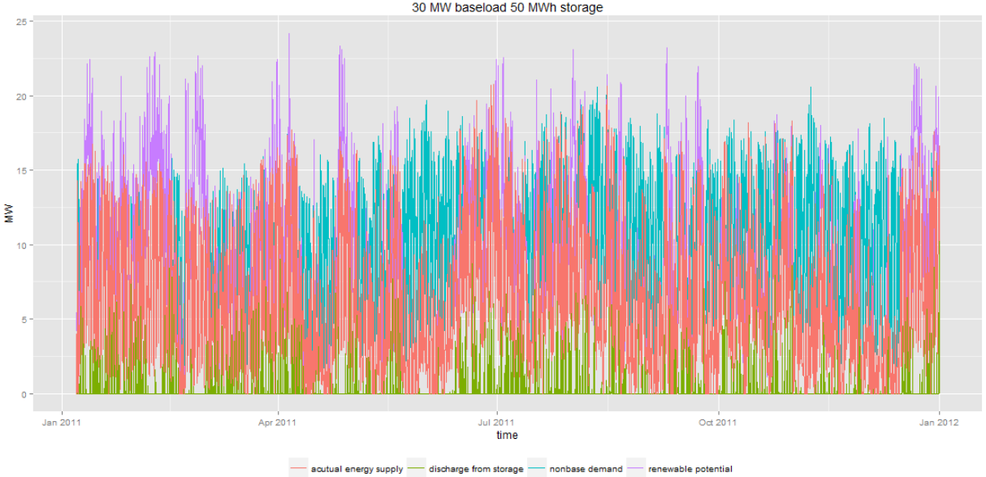Figure 5 is the plot of demand and supply profile with 50MWh of energy storage. By storing the renewable energy when there is excess generation and releasing it when there is extra demand, we are able to reduce the number of hours with unmet demand by 670 hours, and bring up the capacity factor of renewable energy from 26.2% to 28.5%.The average power from renewable energy is brought up from 6MW to 6.5MW.

Fig. 5 Plot of potential and actual energy supply from renewables, the energy discharged form storage, and the non-base demand

Table. 2 The effect of energy storage

|  |  |  |  |
| --- | --- | --- | --- |
| storage capacity | capacity factor of renewable | number of hours demand not met | total unmet demand (MWH) |
| 0MWH | 26.2% | 5191 | 29860.53 |
| 50MWH | 28.5% | 4521 | 25482.56 |

1. Comparing capital cost of UW-CAES with increasing diesel base load

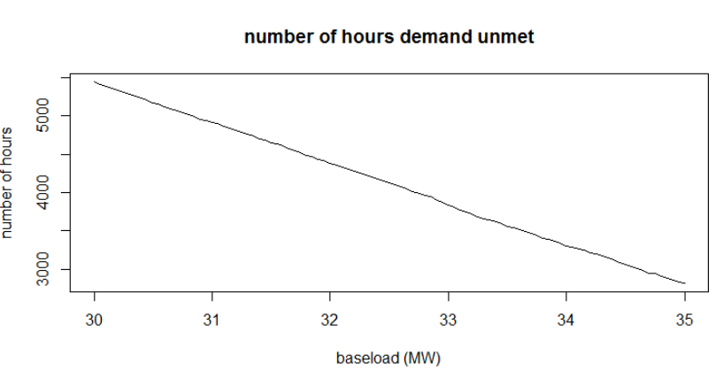It is useful to compare the capital cost of extra diesel and underwater compressed air storage with same level of stability, i.e. the same number of hours of blackout. If the reduced 670 hours of blackout is achieved by increasing base load, an extra 1.3 MW of base load is needed.

Fig. 6 Number of hours demand not met versus different base-load

The average cost of is $0.30/KWH from diesel generation. The combined cost of the 18MW wind farm with energy storage is only $0.15/KWH [3].The capital cost of UW-Compressed Air Energy Storage will not be similar with underground compressed air energy storage, which is $820/KW and $100/KWH [4] [5].

The payback time of the energy storage system will be six to seven years, seen from Figure 7. If consider the typical lifetime of the energy storage to be 20 years, the cost of underwater compressed air is much lower than using only load-following diesel (Table 3).

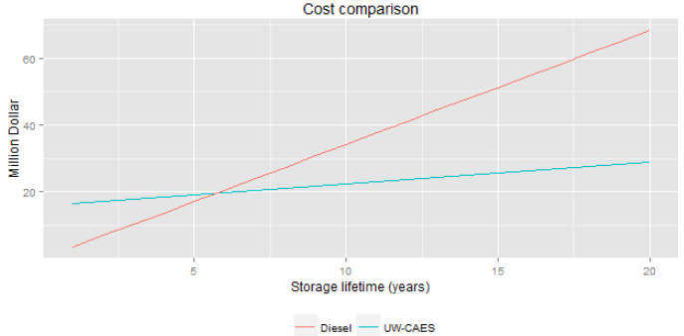

Fig.7 Cost comparison between diesel and UW-CAES

Table.3 Capital cost comparison of diesel and CAES

|  |  |  |
| --- | --- | --- |
|  | Diesel | CAES |
| Infrastructure (million dollar) | 0 | 15.7 |
| Electricity energy (million dollar) | 68.3 | 13.1 |
| Total cost (million dollar) | 68.3 | 28.8 |

**Part 2- Underwater Compressed Air Energy Storage**

1. Feasibility comparison of UW-CAES and pumped hydro storage in Antigua and Barbuda

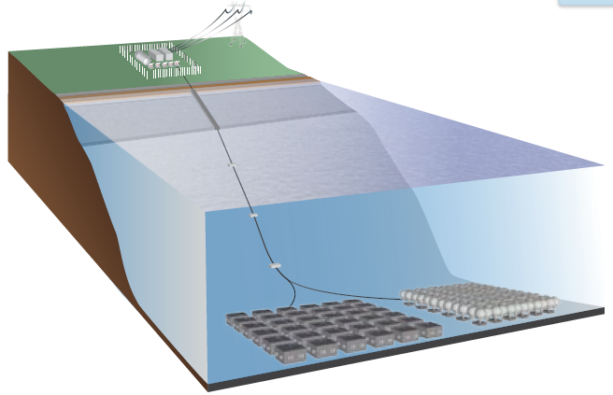There are no large elevations that forms ideal waterway for pumped hydro system. Moreover, existing reservoirs have the risk of drainage in dry season, so that the wind power plant will not be in operation for weeks or months in droughts. Even if we could find other possible locations to build new reservoirs, additional capital cost will be very high. Also, the use of the reservoirs as a pumped hydropower scheme will occupy two reservoirs which effectively cannot be used for domestic water supply. However, the island is surrounded by deep waters, which is ideal for UW-CAES.

Fig. 8 The configuration of the storage system [2]

1. Design theory [6]

The design pressure of an UW-CAES system is determined by the submergence of the air bags. It is the hydrostatic pressure exerted by the water at depth, shown in Eq. (1). Based on the topography [1] of Antigua, the air bags are placed at 500 meters depth in the water, so the storage pressure is 50 bar.

$p_{storage}=p_{atm}+p_{water}gz$ (2)

Taking the storage bag as the control volume, the maximum amount of air that could be stored in each bag can be calculated using the ideal gas law, shown in Eq. (2)

$m_{air}=\frac{{(pV)}_{storage}}{RT_{water}}$ (3)

Two stages of compression and expansion are used to handle large pressure changes during air compression and expansion. When all stages in an air compressor or turbine are identical, the maximum amount of work will be generated by the turbines, while the minimum amount of work will be required by the compressors. So the pressure ratio of the two stages can be expressed by Eq. (3)

$β={\left(\frac{p_{discharge}}{p_{inlet}}\right)}^{1/2}$ (4)

By assuming adiabatic compression and expansion, we could get the air temperature for each step by equation 4 and 5.

$T_{2}= T_{1}β^{\frac{k-1}{k}}$ (5)

$k=c_{p}/c_{v}$ (6)

The work generated from discharging a full bag is given in equation 6.

$W_{turbine}=Q=c_{p}m_{air}∆Tη_{isentropic}η_{turbine}$ (7)

The basic data about the underwater compressed air bags is listed below [7].

Table.4 Data of underwater bags

|  |  |
| --- | --- |
| Parameters of the underwater bags | value |
| Depth (m) | 500 |
| Radius of each bag (m) | 2.5 |
| Mass when fully charged (kg) | 4116.4 |
| Storage capacity (MWH) | 50 |
| Temperature of the Sea, Tsea (K) | 288 |
| Temperature of the atmosphere, T0 (K) | 298 |
| Specific energy discharged (KWH) | 473 |
| Number of bags | 103 |

1. Thermal recovery

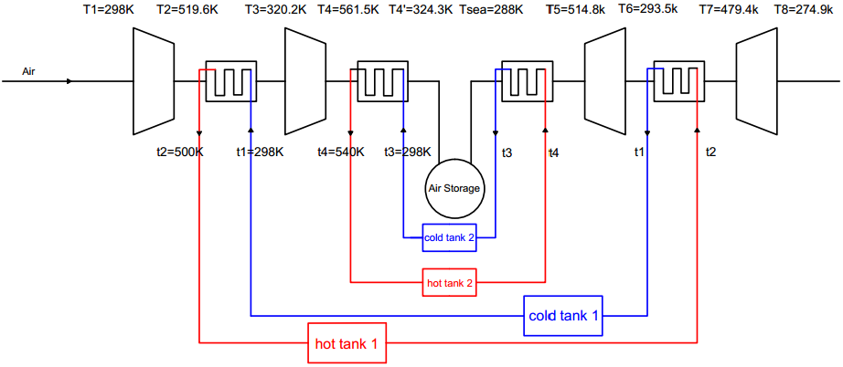

Fig.9 Configuration 1 of the thermal recovery system [8]

In order to improve the efficiency and reduce the use of diesel base load, thermal recovery is essential. Making use of the heat generated by compression to preheat the air before expansion could effectively recycle heat and save a huge amount of energy. Four heat exchangers and four thermal storage tanks are connected to recover the heat.

The system under consideration featured two air compression stages and two air expansion stages. During air compression, the first stage inlet temperature is set to the ambient air temperature. Also, the cold tanks temperatures are set to be the ambient temperature, too, so that no extra coldness is required.

Assuming the effectiveness of the heat exchanger to be 0.9, we could get the output temperature of the air of each stage accordingly, based on equation 8 [9].

Effectiveness: $ε=\frac{{C_{h}(T}_{h,i}-T_{h,o})}{C_{min}(T_{h,i}-T_{c,i})}$ = $\frac{{C_{c}(T}_{c,o}-T_{c,i)}}{C_{min}(T_{h,i}-T_{c,i)}} (8)$

Table.5 Data of the thermal recovery system

|  |  |
| --- | --- |
| Parameters of the system | Value |
| Ambient temperature | 298K |
| Ambient pressure | 1.01MPa |
| compressor isentropic efficiency | 0.8 |
| compressor motor efficiency | 0.95 |
| expander isentropic efficiency | 0.8 |
| expander generator efficiency | 0.97 |

Assume the output temperature of the heat transfer fluid, and the efficiency of the heat exchangers, mass flow rate ${\dot{m}}_{fluid}$ by hour is calculated in equation 9 and 10,

$$q_{fluid}=\frac{q_{air}}{η}= c_{p,fluid}m_{fluid}{∆T}_{fluid} (9)$$

$$q_{air}=w_{ turbine } or {q_{air}=w}_{compressor} (10)$$

In order to be able to work in such a big temperature range (274K to 540K), silicone oil, with a working range from 243K to 553K, is used as heat transfer and thermal storage medium [10] [11].

The volume of the tanks are designed roughly eight times of the maximum volume of the fluid that could possibly going in or out of the tanks. The four vertical cylindrical tanks are identical with a diameter of 9.8m and a height of 9.8m, insulated using fiberglass with a thermal conductivity of 0.04 W/ (m $∙$ K).

Assume that we heat up Hot Tank 1 to 500K and Hot Tank 2 to 540 K in advance to reach steady state.

Table. 6 Temperatures of the heat storage tanks

|  |  |
| --- | --- |
| Tanks | Temperature |
| Cold tank 1 | 298K |
| Hot tank 1 | 500K |
| Cold tank 2 | 298K |
| Hot tank 2 | 540K |

1. Evaluate the performance of the system

Table.7 Performance of the system

|  |  |  |
| --- | --- | --- |
|  | discharging | charging |
| Total number of hour | 1502 hour | 2065 hour |
| Total energy | 4377.9 MWH | 7459.3MWH |
| Average power | 0.51MW | 0.87MW |
| Max power | 12.4MW | 17.6MW |

1. Overall efficiency

The overall efficiency of the system is 58.69%, which is calculated by the total output energy over the year divided by the total input energy over the year.

$$η=\frac{{Σ_{i=1}^{8616}W}_{out,i}}{{Σ_{i=1}^{8616}W}_{in,i}} (11)$$

1. Tracking the storage volume of the air bags

|  |  |
| --- | --- |
|  |  |
| Fig.10 Storage volume profile of the year | Fig.11 Histogram of storage volume |

Figure 10 and figure 11 indicate the charging and discharging times and the usage of the storage. But unfortunately, for almost half a year, 3922 hours, the bags are empty, which means the generation is not enough.

1. Heat load in the storage tanks

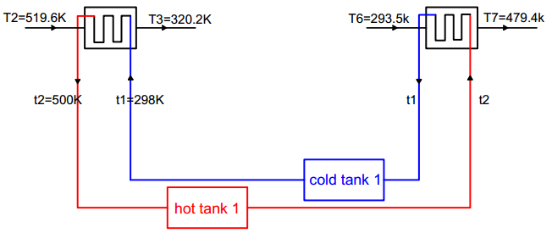Initial volume of the oil in four tanks are set to be half of the tank volume, 218.5m3. Because the two loops behave quite similarly, we could just analyze the first one. Since the tanks and heat exchangers are connected together, the total volume of the oil in loop one is constant. When charging, the fluid moves from cold tank to hot tank, when discharging, fluid moves the other way around.

Fig. 12 The first loop of the thermal recovery system

The problem (demonstrated in Figure 14 (a)) is that there’s a danger of draining the hot tank and overflow the cold tank. It is not surprising because there’s energy loss during charging and discharging, so we have to make it up using extra heat. Therefore, we need to pump the fluid back, and heat it up (350.5MWH/ year) to the hot tank temperature before it’s going to drain.

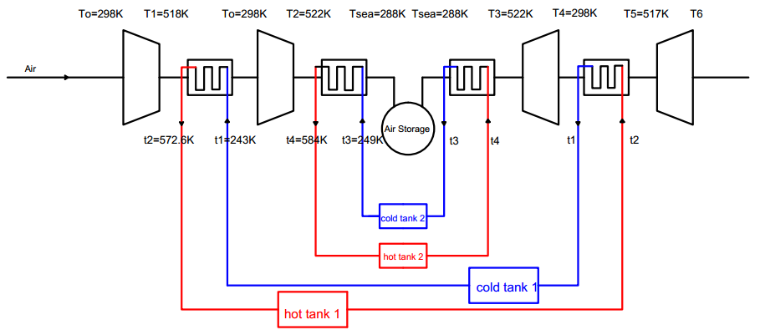Otherwise, we could use heat source to maintain perfect temperature exchange like the following configuration. In that case, the volume in each tank is exactly a mirror to the other, as shown in figure 14 (b). But the disadvantage of this system is obvious too, we have to heat up the fluid by 50~60K to reach the hot tank temperature as well as cool it down to 40~50 K below than ambient temperature. That is over 1500MWH a year, which doesn’t make sense.

Fig. 13 Configuration 2: another temperature setting involving extra heat to maintain perfect temperature change

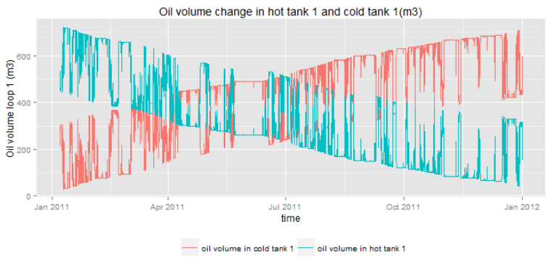

Fig. 14 (a) Oil volume change in hot tank 1 and cold tank 1

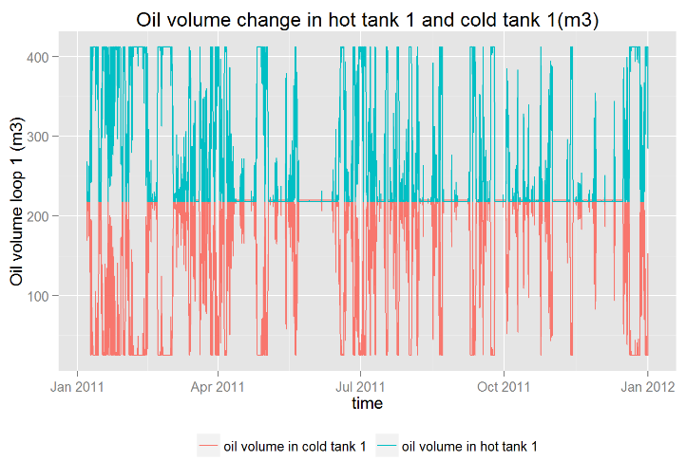

Fig. 14 (b) Oil volume change in hot tank 1 and cold tank 1

Heat load and cold load are the amount of heat or cold the fluids has to remove or supply, i.e. the $q_{fluid}$ in equation 8. The heat load is the amount of heat that has to be removed from the compressor. The cold load is the heat we have to put in in order to preheat the air before expansion. They reflect the amount of heat we’re able to store and recycle.

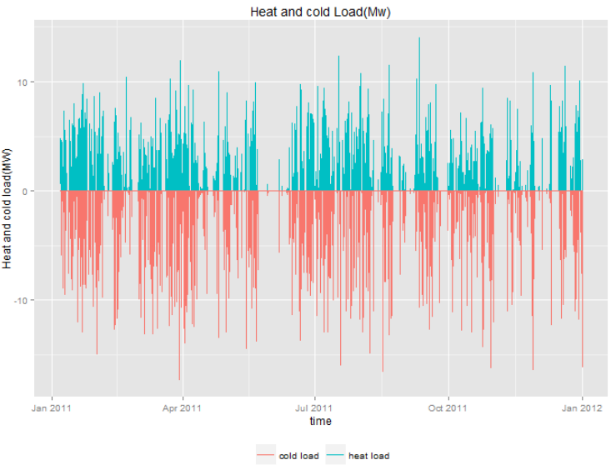

Fig. 15 Heat and cold load of the year.

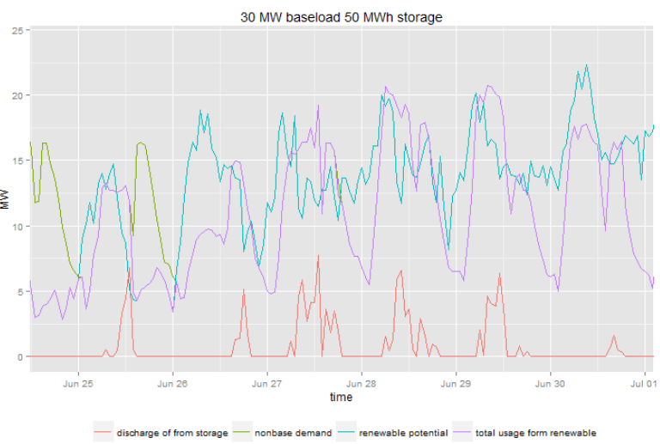

Fig.16 Energy generation and demand, Week of June 25th 2011

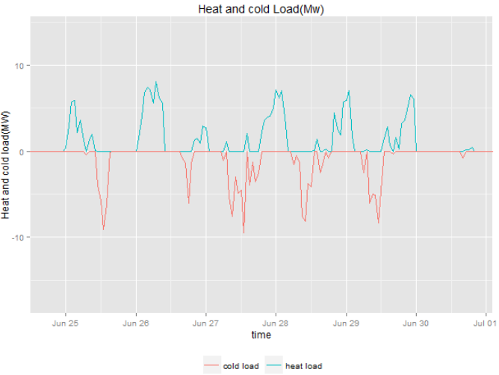

Fig.17 Heat load and cold load, Week of June 25th 2011

Let’s take a close look at the last week of June in figure 17, comparing it with the energy profile, figure 16. In the first two days of the week, there’s unmet demand. From the plot of heat and cold load, the discharge became zero after 3 pm on June 25th. And then there’s a blackout. But starting from the third day, the storage system is able to meet the demand. As shown in the plot, when the purple curve is above the blue curve corresponding to the storage discharging. We could also note that the shape of the discharge of storage correspond to the shape of cold load, the difference is the efficiency of turbines and heat exchangers.

1. Heat loss of the hot tanks

Table 8 Data of thermal storage tanks

|  |  |
| --- | --- |
| Variables | Value |
| Diameter | 9.8m |
| Height | 9.8m |
| Volume | 750 m3 |
| thickness | 0.1m |
| material | Steel |
| conductivity | 55 w/(m*k) |
| insulation material | Fiberglass |
| conductivity of insulation | 0.04 w/(m*k) |
| initial volume in hot tanks | 60% tank volume |
| initial volume in cold tanks | 40% tank volume |

The total heat loss of the year is 133MWH. The average heat loss is 11.5 KWH. It is economical to compensate this heat from solar thermal devices, like the practice of hydrostor in their project in Toronto [3].

**Part 3- Discussion and conclusion**

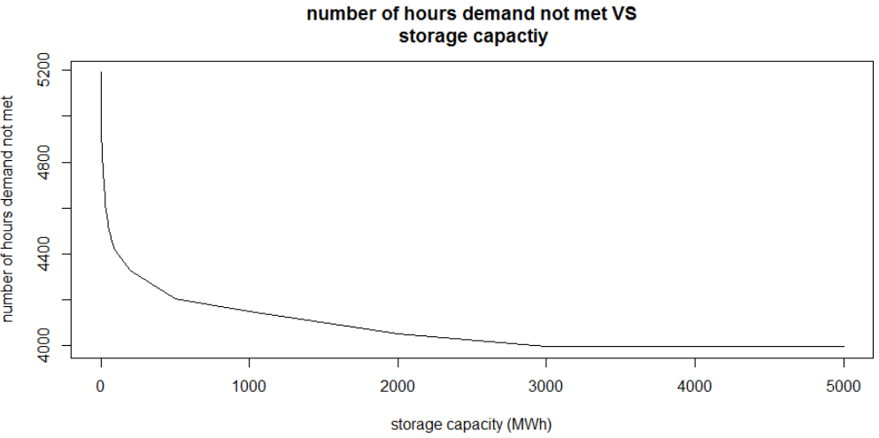From the beginning of the second part of the report, the average potential generation is 37.6MW, while the average demand is 39.5MW. It is interesting to look at the limit of picking up renewable energy with this system. From figure 15, the number of hours that demand not met levels out at 4000 hours when the storage capacity is close to 3000 MWH. That means if we are able to capture all the available renewable energy, we can only reduce the outrage times to a very limited number.

Fig.18 The limitation of effects of current installation of baseload and renewables

Therefore, the generation is not enough to meet the demand. An extra diesel generation or renewable energy generation is needed. But with current base-load, a higher penetration level of renewable energy would probably lead to higher requirement for grid stability. It’s better to increase the base-load according to the budget, which could decrease the total number of hours of unmet demand linearly as shown in figure 6.

Since the island has the proper geographic condition to build a 10 MWH pumped hydro, and it’s cheaper than UW-CAES, it would be a good idea to combine pump-hydro energy storage with UW-CAES. UW-CAES could be a complement for pumped hydro. The overall performance would be slightly better, because pumped hydro system has a higher overall efficiency.

There are still some challenges for UW-CAES.

1. We need to maintain constant temperature of the heat tanks using extra heat source, for example solar thermal devices or the output work of the turbine. The overall heat loss would be 133MWH, which would results in the decrease of efficiency from 58.69% to 57.2% if we don’t use other renewable sources.
2. The charging and discharging power varies a lot because of the instability of wind energy and demand. That would results in the drop in efficiency of compressors and turbines because of part load, which would lower the system’s overall efficiency.
3. A well designed highly efficient heat exchanger is needed to get the desired temperature change. Now we’re assuming an effectiveness of 0.9.
4. The oil volume in the thermal storage tanks has to be monitored closely, because there’s a danger of draining hot tanks and spilling over the cold tank. The heat transfer fluids need to be heated up and pumped back to the hot tank on a regular basis.

**References:**

[1] NORPLAN report, Ministry of agriculture, lands, housing and the environment, pumped hydro in Antigua and Barbuda, report on prefeasibility assessments, Jun 26, 2014.

[2]<http://www.firstsolar.com/~/media/documents/data-sheets/products/module%20data%20sheet/pd-5-401-03_series3black-4.ashx>

[3] Hydrostor Inc - Underwater Compressed Air Energy Storage, <http://homerenergy.com/pdf/hydrostor-whitepaper-11-4-2013.pdf>

[4] EPRI, "Wind Power Integration: Energy Storage for Firming and Shaping," EPRI, Palo Alto, CA 1008388, 2005.

[5] Succar, Samir, and Robert H. Williams. "Compressed air energy storage: theory, resources, and applications for wind power." Princeton environmental institute report 8 (2008).

[6] Cheung, Brian C., Rupp Carriveau, and David S-K. Ting. "Parameters affecting scalable underwater compressed air energy storage." Applied Energy 134 (2014): 239-247.

[7] Pimm, Andrew J., Seamus D. Garvey, and Maxim de Jong. "Design and testing of energy bags for underwater compressed air energy storage." Energy 66 (2014): 496-508.

[8] de Biasi, Victor. "Fundamental analyses to optimize adiabatic CAES plant efficiencies." Gas Turbine World 39.5 (2009): 26-28.

[9] McDonald, André Garcia, and Hugh Magande. Introduction to thermo-fluids systems design. John Wiley & Sons, 2012.

[10]Dincer, Ibrahim, and Sadik Dost. "A perspective on thermal energy storage systems for solar energy applications." International Journal of Energy Research 20.6 (1996): 547-557.

[11] Hartmann, Niklas, et al. "Simulation and analysis of different adiabatic compressed air energy storage plant configurations." Applied Energy 93 (2012): 541-548.